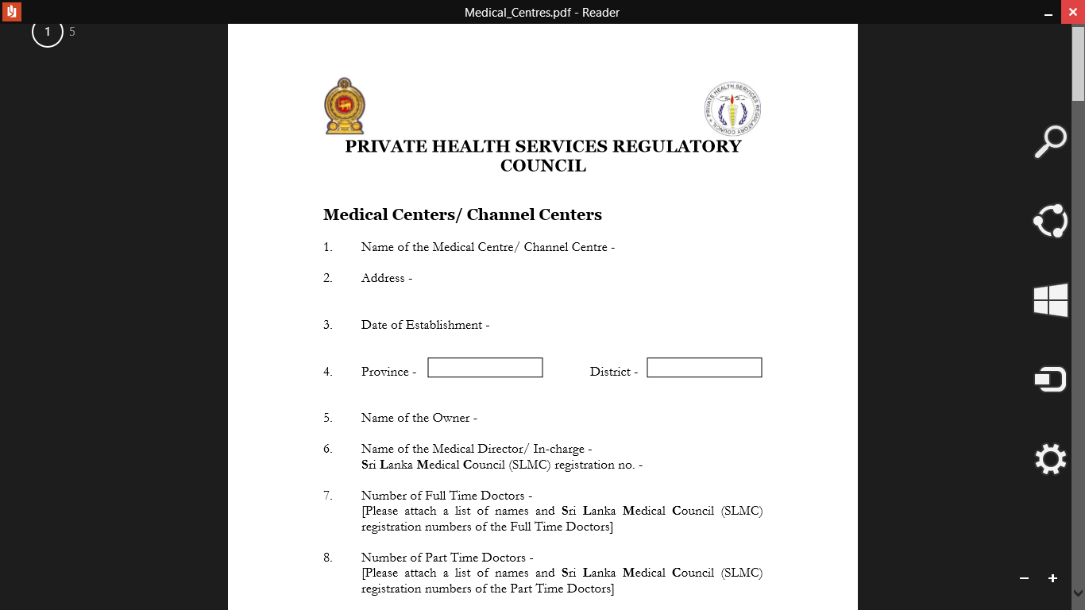 **Channel Centers /Screening Centre**

1. **Name of the Medical Centre/ Channel Centre -** Lal Channel Service

**2. Address –**No 08, H.M. Mawatha, Welimada

**3. Date of Establishment -** 25.01.2008

**4. Province-** Uva **District -** Badulla

**5. Name of the Owner -** P.T.M. De Silva

**6. Name of the Medical Director/ In-charge -** No

**Sri Lanka Medical Council (SLMC) registration No. –**

**7. Number of Full Time Doctors –**None

**[Please attach a list of names and Sri Lanka Medical Council (SLMC) registration numbers of**

**the Full Time Doctors]**

**8. Number of Part Time Doctors –**None

**[Please attach a list of names and Sri Lanka Medical Council (SLMC) registration numbers of**

**the Part Time Doctors]**

**9. Name of the Nurse In-charge –**None

**Sri Lanka Medical Council (SLMC) registration No.**

**10. Number of Nurses -**02

**11. Consultation Rooms -** 05

**a.**

|  |  |
| --- | --- |
| **Number of consultation rooms** | **05** |
| **Square area of the each room (Minimum floor area 70 sq.ft. and height 8 ft.)** |  |

Adequate

**b. Equipments**

Adequate

Adequate

|  |  |
| --- | --- |
| **Examination bed** |  |
| **Table and chairs** |  |
| **Wash basin** |  |
| **Weighing scale** |  |
| **Adequate ventilation and illumination** |  |

**c. Waiting Area**

Adequate

|  |  |
| --- | --- |
| **Seating facilities for minimum of 10 persons per consultation room with sanitary facilities** |  |
| **Adequate ventilation and illumination** |  |

**12. Sample Collection Room –**

|  |  |
| --- | --- |
| **Floor area (Minimum floor area 100 sq.ft.)** |  |
| **Adequate sanitary facilities** |  |

**a.**

**b. Equipments - No**

|  |  |
| --- | --- |
| **Arm chair** |  |
| **Bed** | - |
| **Safe waste disposal** |  |
| **Toilet facilities** | - |
| **Adequate illumination** |  |

**13. X-Ray Room –** No

|  |  |
| --- | --- |
| **Registration number and date of the license issued by the Atomic Energy Authority** |  |

**14. Emergency Treatment Unit -** No

|  |  |
| --- | --- |
| **Floor area (Minimum of 100 sq.ft. per patient)** |  |
| **Suitable floor and walls for easy cleaning** |  |
| **Adequate ventilation and illumination** |  |

**a.**

|  |  |
| --- | --- |
| **Oxygen** |  |
| **ECG recorder** |  |
| **Nebulizer** |  |
| **Sucker** |  |
| **Emergency trolley with supplies** |  |
| **Necessary facilities and equipment for resuscitation** |  |
| **Laryngoscope** |  |

**b. Equipments -** No

**15. C.S.S.D. -**

|  |  |
| --- | --- |
| **Auto clave** |  |
| **Sterilization facilities** |  |

|  |  |
| --- | --- |
| **Dry and clean storage facilities with provision to maintain cold chain** |  |

**16 Indoor Pharmacy/ Drug Store -** No Pharmacy

**17. Parking**

|  |  |
| --- | --- |
| **Number of parking slots** |  |

**18. Waste Disposal**

|  |  |
| --- | --- |
| **Method of Clinical Waste Disposal**  **(According to the Central Environmental Authority requirements)** | Satisfactory |

Advised to hand over Sisiliaro Company

**19. Company/ Business registration No. -** H 536

**20. Provincial Director’s Comments -**

Recommended / Not Recommended for Registration - Year 2023

**Name of the Provincial Director of Health Services - Dr.J.C.M.Tennekoon**

**…………………….. ………………………… ……………………….**

**Signature Seal Date**